2018380039_Dikshya Kafle Lab report DBMS

Name: Dikshya Kafle

Student Number: 2018380039

Experiment 2: Manipulate the Data in Table

## Goal

1. Master all kinds of data operation about basic table in GUI.

2. Familiar with SQL statements for data insertion, modification and deletion of basic tables.

3. Master the SQL statement of data query.

4. Master the basic knowledge of SQL query performance analysis.

5. Understand TPC-H benchmark database.

## Content

1. Use SQL statement to insert all the tuples into the database SPJ_MNG and university which have been list in the previous experiment.
2. Modificaion the data of tables with SQL statement.
3. Modify one tuple in the table of student
4. Delete one tuple from table of student.
5. In the database of SPJ_MNG, use SQL statement to do the following update operations:
6. Change the color of all red parts to blue.
7. Part P6 supplied by S5 for J4 is replaced by S3, please make necessary modification.
8. Delete S2 record from supplier table and delete corresponding record from supply table.
9. Please insert (S2, J6, p4200) into the supply table SPJ.Finish the following queries about the database university with SQL statement.
10. Use three different ways (SQL statement) to find the student ID and name of all students who take “Database System Concept”, and then analyze and compare the performance of each query process.
11. For university database, complete the following data query with SQL statement
12. Query the total score of credits obtained by each student , and output the student ID, name and credit obtained in the order from high to low.
13. Query the name of the student: the student has taken all courses and one of the courses has a grade of better than B .
14. Use at least three different SQL statements to query the university database: query the student ID and name of the course named "database", and then design the experiment by ourselves, compare and analyze the efficiency of the three kinds of query with data, and analyze the reasons.

**Use SQL statement to insert all the tuples into the database SPJ_MNG and university which have been list in the previous experiment.**

**S table:**

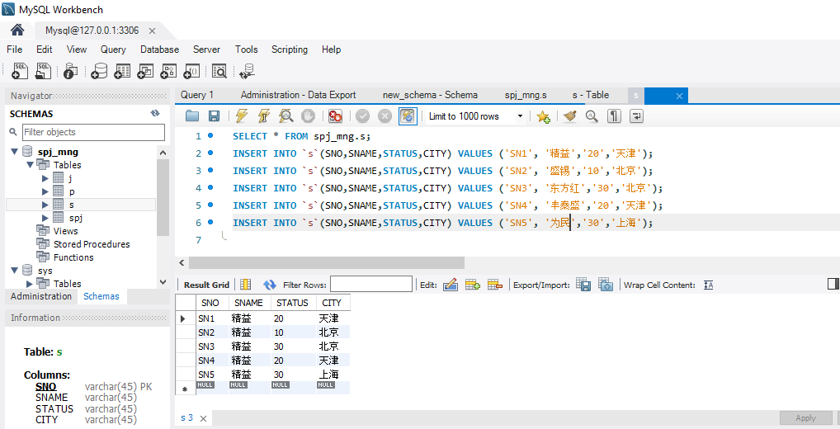

**Spj table:**

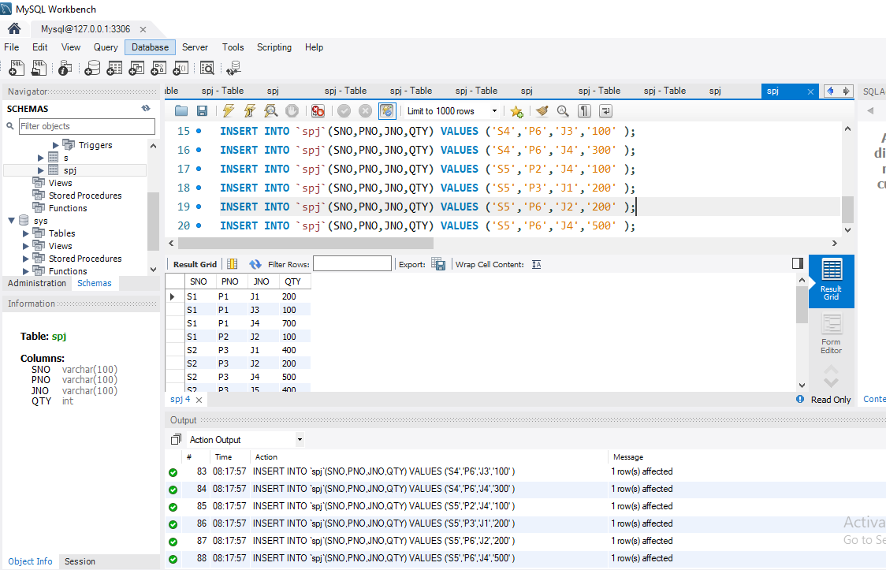

**J table:**

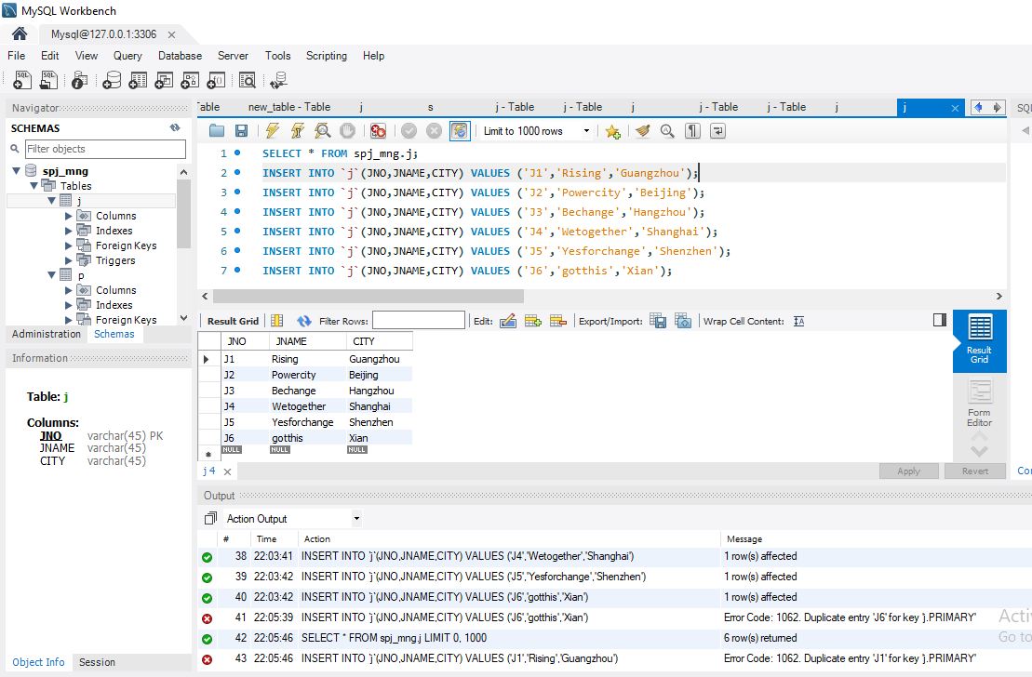

**P table:**

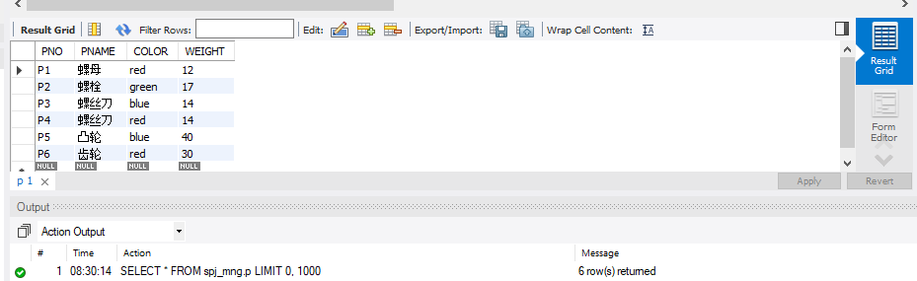

**Modificaion the data of tables with SQL statement:**

**Modify one tuple in the table of student:**

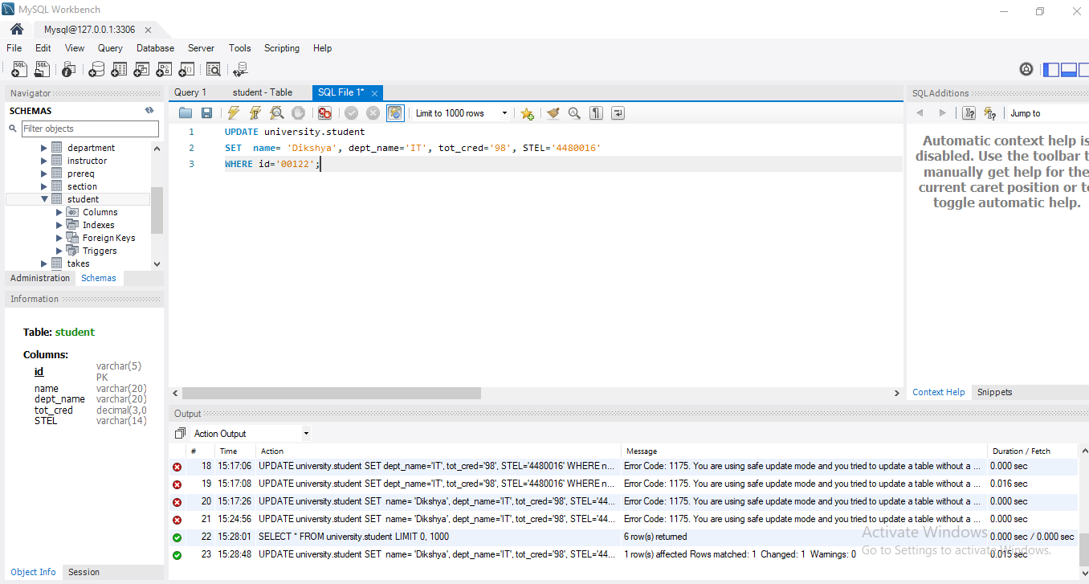

**Delete one tuple from table of student:**

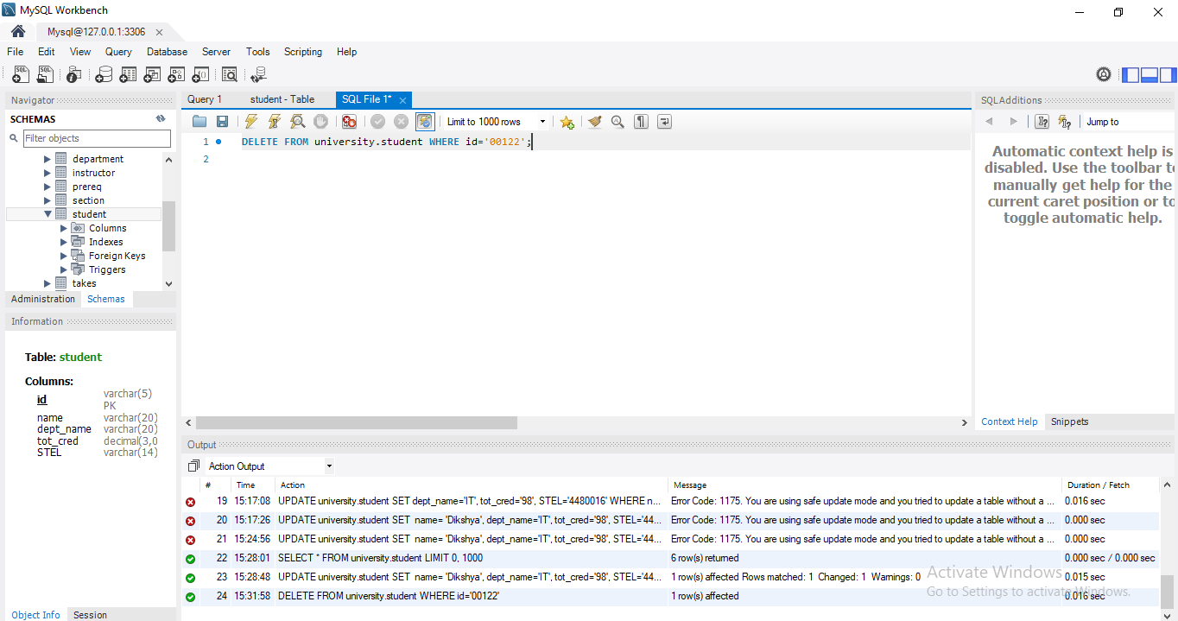

**In the database of SPJ_MNG, use SQL statement to do the following update operations:**

**Change the color of all red parts to blue:**

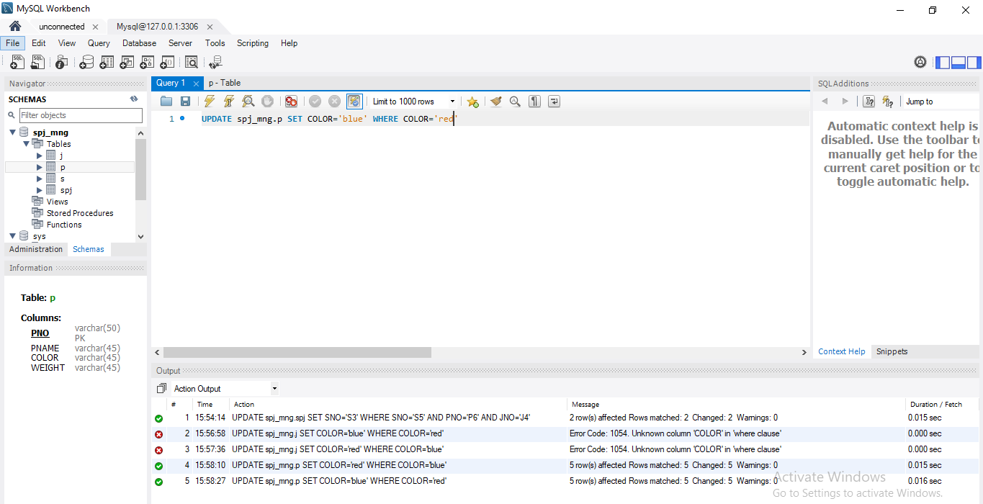

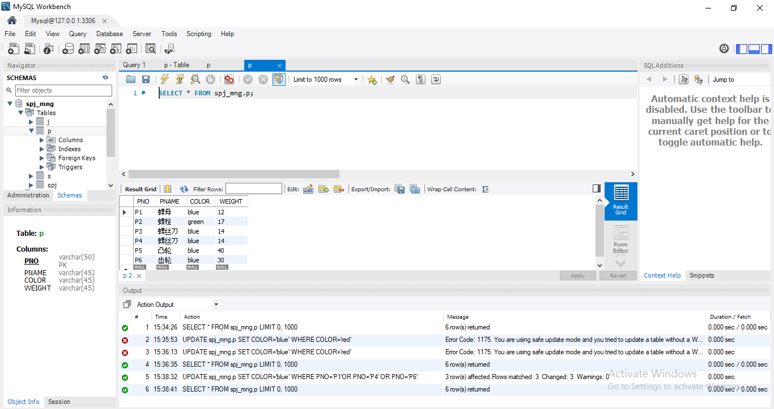

**Part P6 supplied by S5 for J4 is replaced by S3, please make necessary modification.**

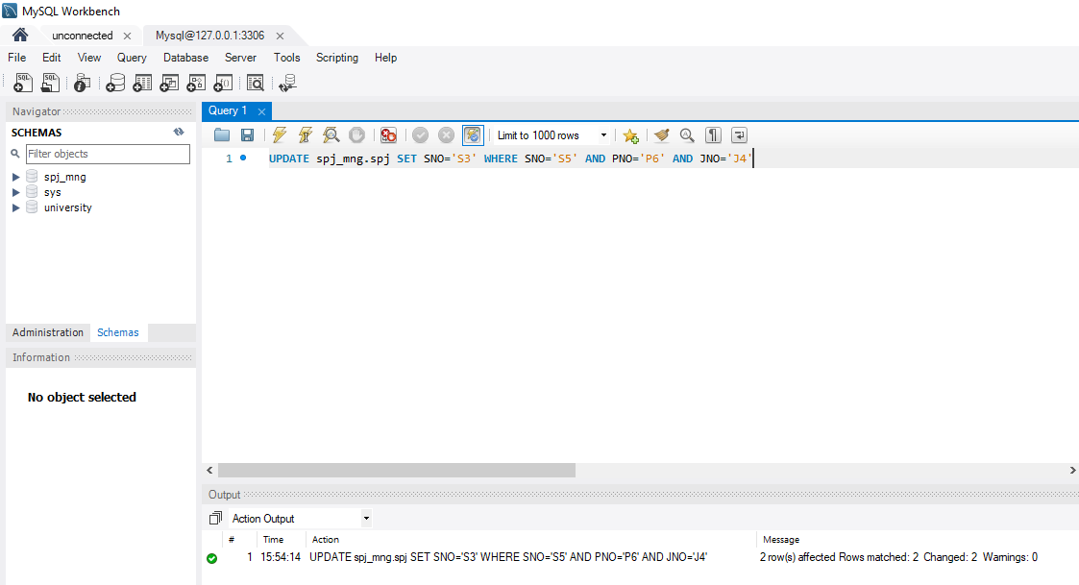

**Delete S2 record from supplier table and delete corresponding record from supply table.**

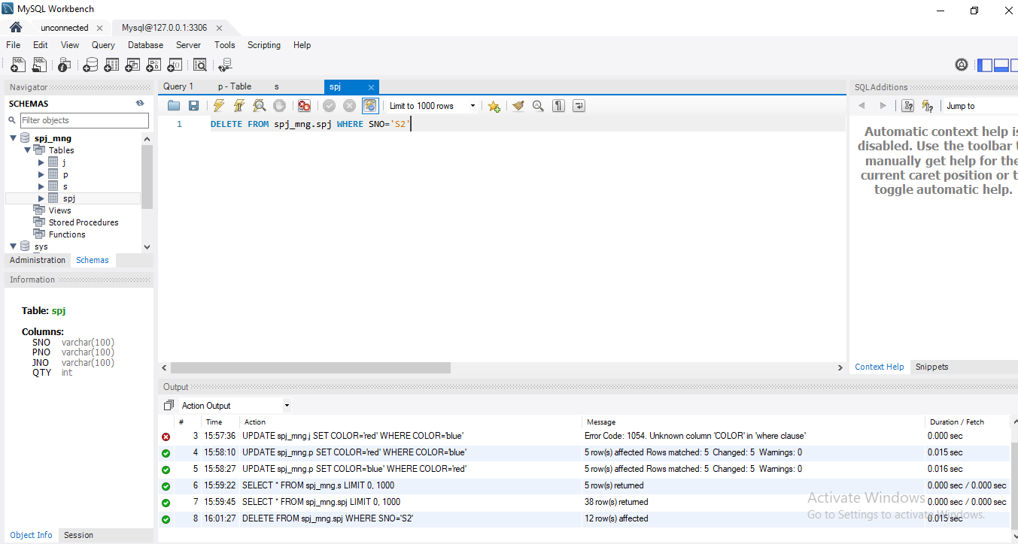

**Please insert (S2, J6, p4200) into the supply table SPJ.Finish the following queries about the database university with SQL statement**

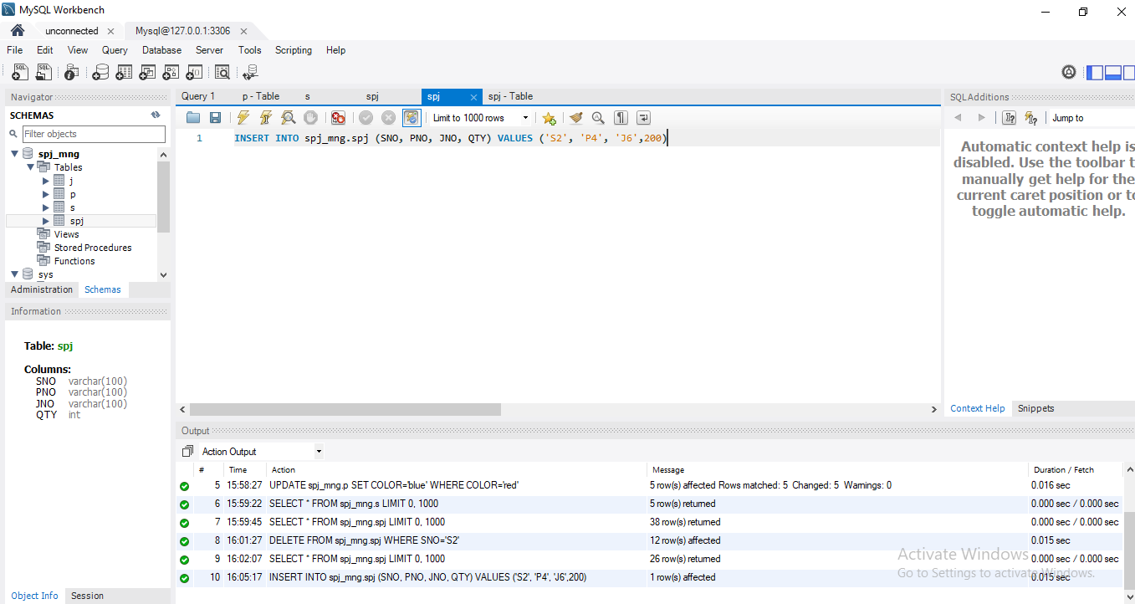

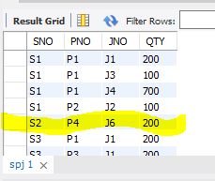

**Use three different ways (SQL statement) to find the student ID and name of all students who take “Database System Concept”, and then analyze and compare the performance of each query process.**

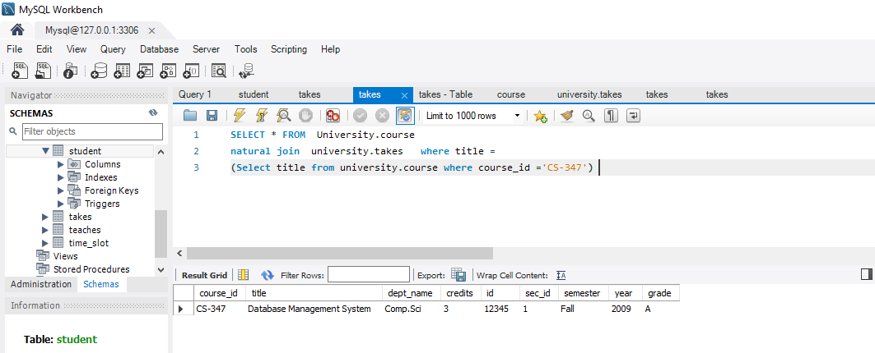

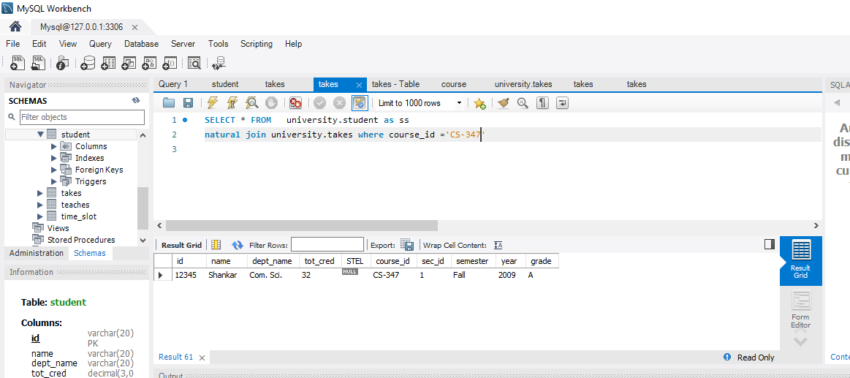

**For university database, complete the following data query with SQL statement**

**Query the total score of credits obtained by each student , and output the student ID, name and credit obtained in the order from high to low**.

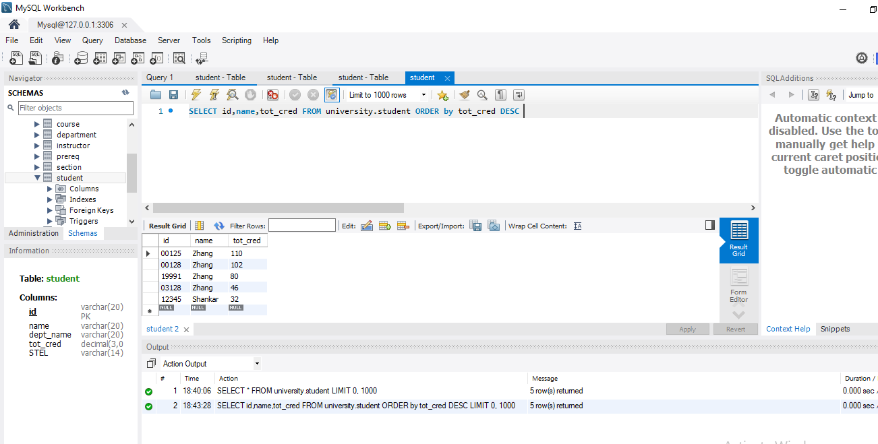

**Query the name of the student: the student has taken all courses and one of the courses has a grade of better than B**

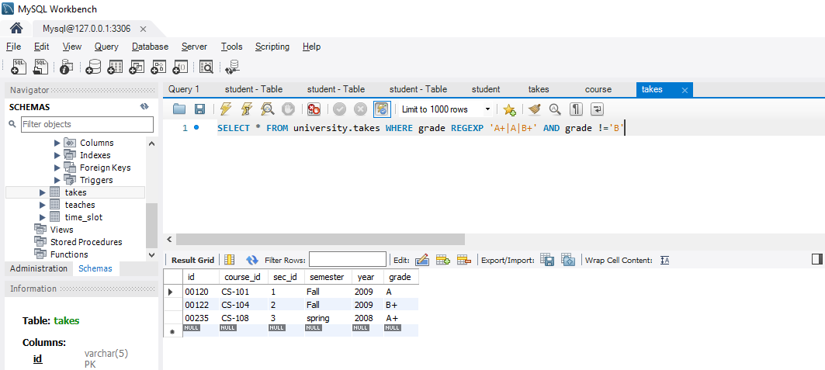

**Problem:**

Had some simple syntax error. Because of the complexity of the question had hard time figuring it out.

**Solution:**

To solve these problems I looked for information in internet. In order to understand some questions and procedure I also asked the teacher to help me understand them. And provided instructions helped to solve some of my errors during the experiment.

**Summary:**

From this experiment I have learned SQL statement to create database and table. I have learned how to update and delete methods of database and table. Have become familiar with SQL statements of data insertion, modification and deletion of basic tables. Learned all kinds of data operation about basic table in GUI. This experiment allowed us to understand SQL statement of data query. Therefore, I have been able to have basic knowledge of SQL query performances and analysis.